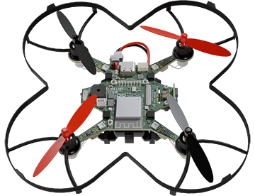

|  |  |
| --- | --- |
| **CodeAIR Mission 4 Assignment** | **Name:** |
| **Pre-Mission Preparation** | |
| This mission is all about keeping you and CodeAIR safe. What are some ways you can keep yourself safe while working with a drone? |  |
| You will use CodeAIR’s LEDs and speaker. What code do you remember to control the LEDs and speaker? |  |
| **Mission 4 Checks – Flight Safety** | |
| Objective #1  What is the safe plan you will implement for running code on CodeAIR?  What is the code that waits for a button press? |  |
|  |
| Objective #2  Describe what a bad bounce is.  What are two ways to debounce a button press? |  |
|  |
| Objective #3  How did you improve the UX during this Objective? |  |
| Objective #4  Why do you need to import the **flight** module? |  |
| Objective #5  What is one purpose of a function?  What is the purpose of the **do_launch** variable?  What is returned by the function you defined? |  |
|  |
|  |
| Objective #6  Which direction do black propellers turn?  Which direction do red propellers turn?  Why do the propellers spin in different directions? |  |
|  |
|  |
| **Post-Mission Reflection** | |
| What is something you learned about drones from this mission? |  |
| What is something you learned about coding during this mission? |  |